**RIPHAH INTERNATIONAL UNIVERSITY, ISLAMABAD**



**Lab 7**

**Bachelors of Computer science – 5th semester**

**Subject:** Operating System Lab

**Submitted to:** Ma’am Kausar Nasreen Khattak

**Submitted by:** Munaza Malik

**Sap Id:** 44956

**Date:** 7th October, 2024

**Lab Task:**

**pwd (Print Working Directory) :** Shows the full path of the current directory you are in.

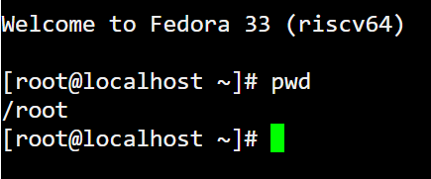

**ls (list) :** Lists files and directories in the current directory.

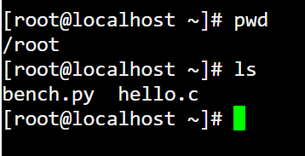

**mkdir (make directory) :** Creates a new directory.

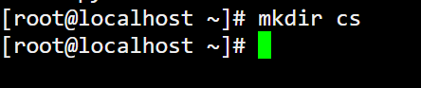

**cd (change directory) :** Changes the current directory to another.



**rmdir (remove directory) :** Deletes an empty directory.



**rm -r (Remove Recursively) :** Deletes a directory and all its contents.



**cp (copy) :** Copies files or directories to a new location.

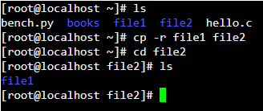

**mv (move):**



**touch:** Creates an empty file or updates the timestamp.

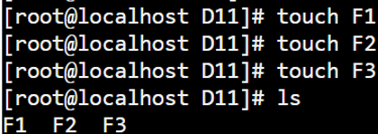

**Absolute Path:**

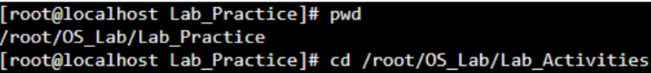

**Relative Path:**

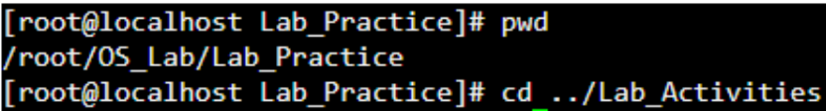

**Using Symbolic Method:**

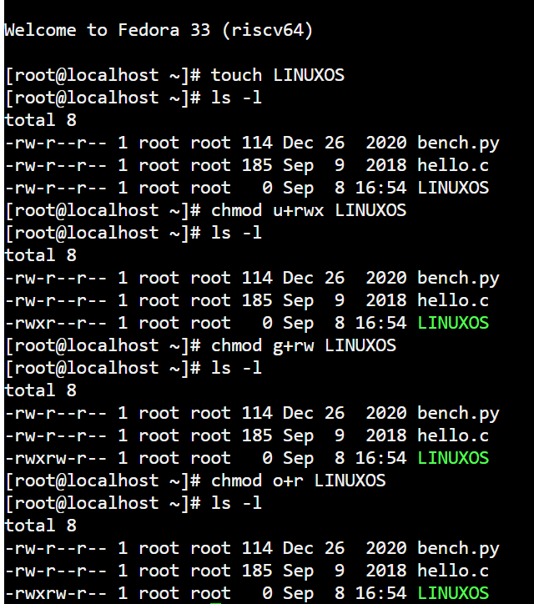

**Using Numerical Method:**

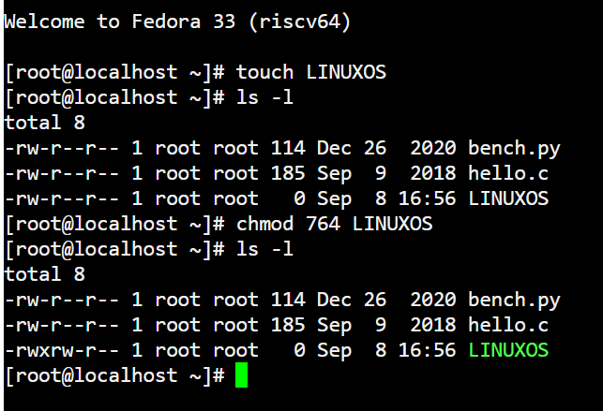

**cat:**

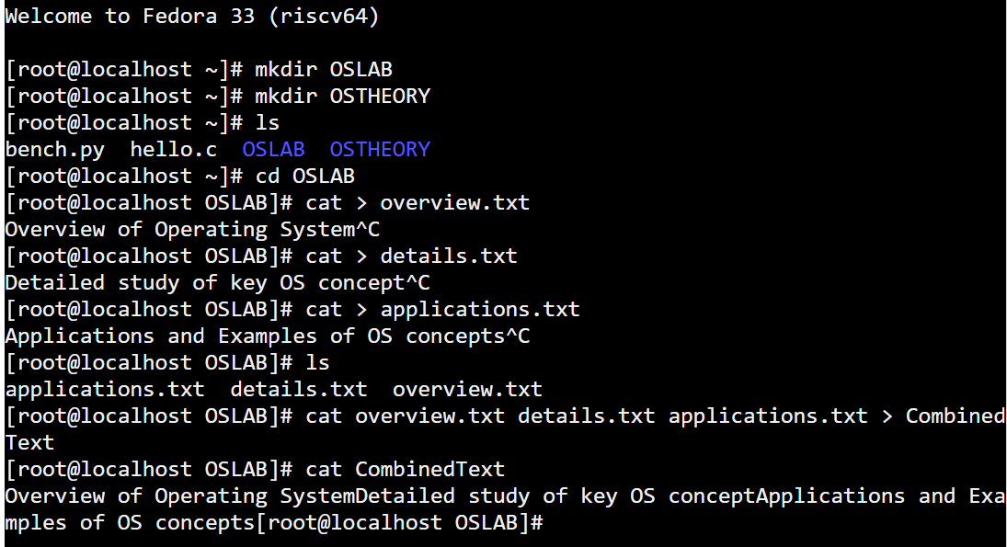

**The time of the log entry in the 12-hour format with AM/PM.**

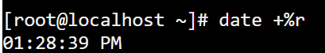

**The date of the log entry in the "Month Day Year" format.**



**OR**

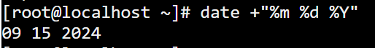

**The full weekday name for the log entry.**



**The numerical representation of the month.**



**The last two digits of the year.**



**24-hour format with only hours and minutes**



**the current year in four-digit format**



**current date in a combined format of numerical day, month, and year and Time**

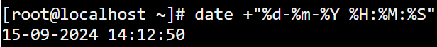

**cal**

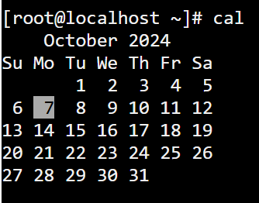

**Yesterday date:**

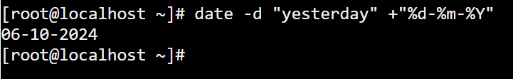

**tomorrow date:**



**10 days ago:**



**Calculator of month December 2024:**

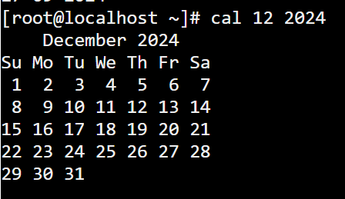

**print a welcoming message that includes the current date and time:**



**Clear screen:**



**sort strings in reverse alphabetical order:**

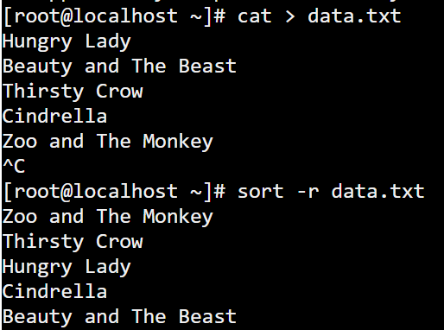

**sort file based on the values in the second column:**

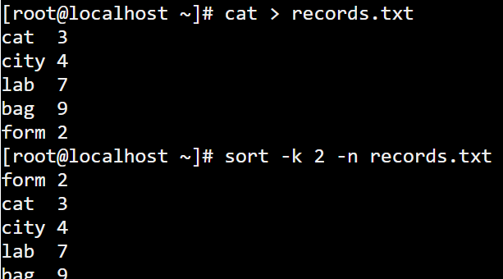

**-o Option:**

**example.c:**



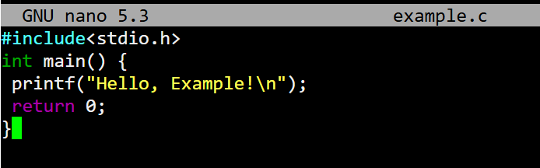

To compile this program with a custom output name, we would use the -o option like this:

**gcc -o my_example example.c**



**Chmod command:**



**nano hello.cpp**



